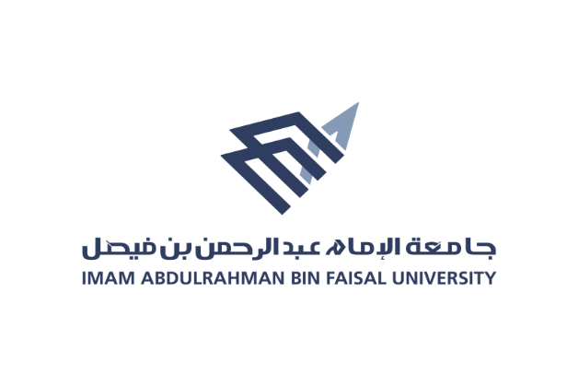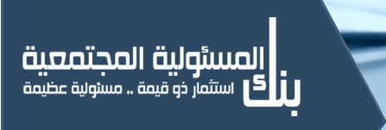

**كليــــــــة التــمــــريض**

**College of Nursing**

**Annual Report 2017 - 2018**

1. **Scitech Event Report**

The College of nursing was participating in the “Ninth Exhibition of the Science & Technology”. This event was held on 27th and 28th 29th and 30 of March 2017 in “Sultan Bin Abdulaziz Science & Technology Center”.

Our college participation was consisted of three parts, which are:

1. First Aid training about fractures, amputations, burns, and bleeding.

2. CPR training.

3. Chocking training for adults and infants.

The students were explained these three procedures after trained well in the lab. Faculty and lab managers were supervised the students during their explanations and discussion with the target group. Target group was the girl and boys students from the three levels (primary, intermediate and secondary) and teachers.

**Objectives:**

1. Present to the community about the college of Nursing and its vision and mission which clear in the banners.

2. Explain to the target group the three procedures in easy and simple in order to facilitate the understanding from the target group

3. Achieve the social responsibility through this event as a part of the community services.

**Activities:**

1. The students and the teachers started with the part of the first aids, and then the CPR training, finally the chocking training for adults and children.

2. The way of the explanation was by Arabic language due to the target group of the event.

3. There was active discussion and interaction as some of the students asked to clarify some points.

4. The students were willing to answer the questions that asked from the target group.

5. There was a demonstration by the target group of the procedures.

6. The students met the Presidents of King Fahad University of Petroleum and Minerals and they were answering his questions about the CPR.

7. The director of Scitech was motivate his employee to learn more about the CPR procedure and the students were managing the discussion.

8. We asked the director of Scitech for collaboration with the collage to get trained to the CPR and he was willing to collaborate with us.

9. Overall, the event was successful and achieves its goal through the community service.

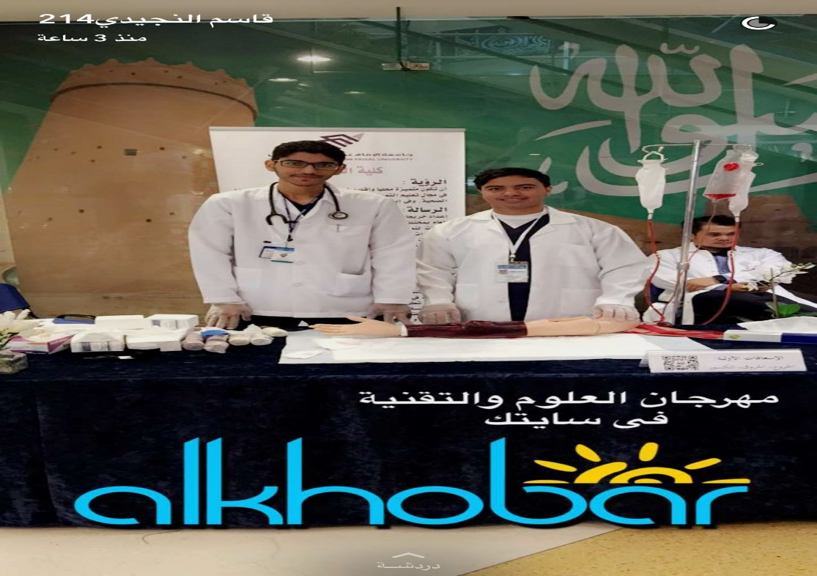

1. **Breast cancer**

By five different corners, Community service and awarness Unit was participating at the Breast Cancer awareness for the academic year 2017-2018 with student activity **(17 \10\2017).**

The day was started with lecture presented by Dr. Afnan Al-Muhanna which arranged by unit.

Nineteen students were participated in the activity. They were distributed to different corners.

First corner was the reception (3 students from 4th year) which they responsible for decorating and distributed the booklet to visitors.

Second corner was Guesting, prepared by 4 students from 4th year.

Third corner was psychological support arranged by 3 students from 4th year which teach the visitor about how will deal with the person who has the breast cancer.

Fourth corner which divided to two group of students, they teach the visitor about breast self-examination (6 students from 4th year)

The last corner was arranged by 3 students from 4th year, they ask the visitor some question and give them gifts.

Finally, The Dean of the Nursing College Dr. Friyal Al-Qahtani opened the corners.

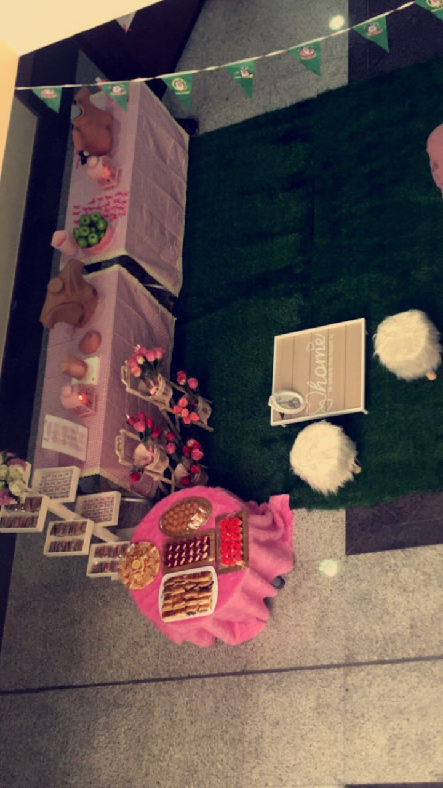

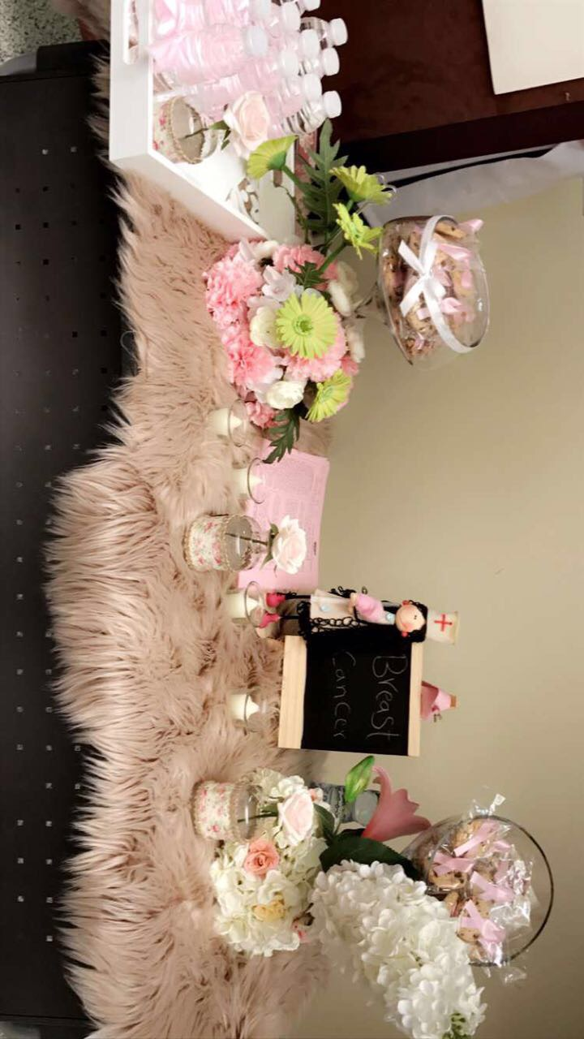

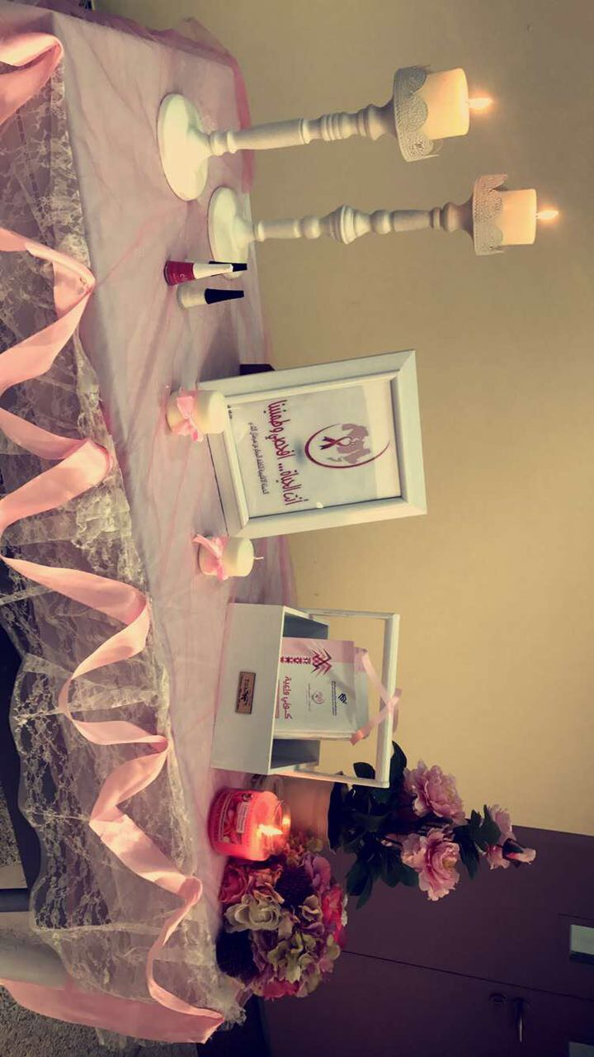

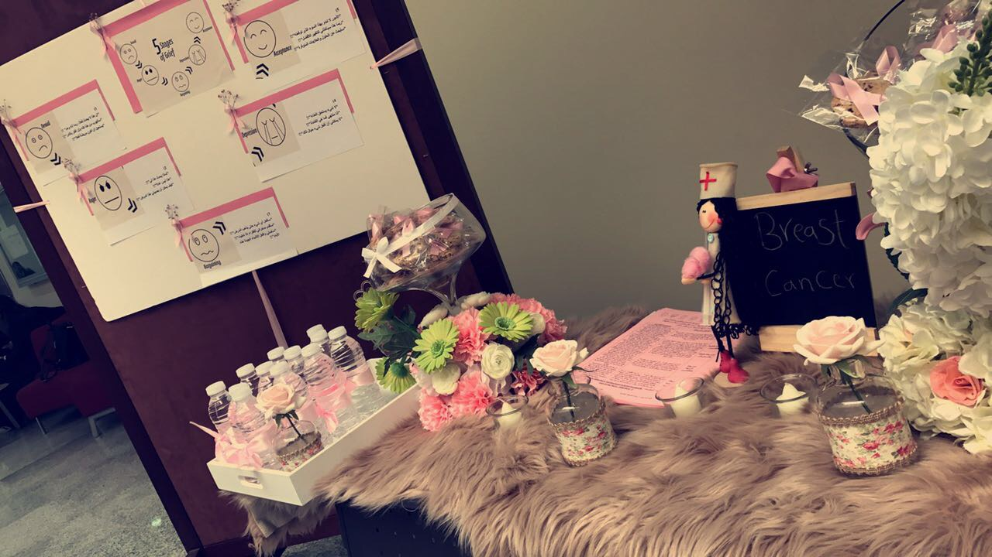

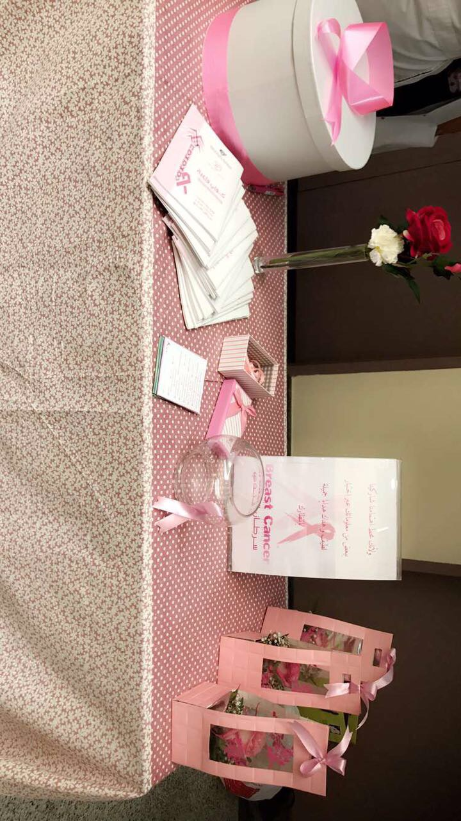

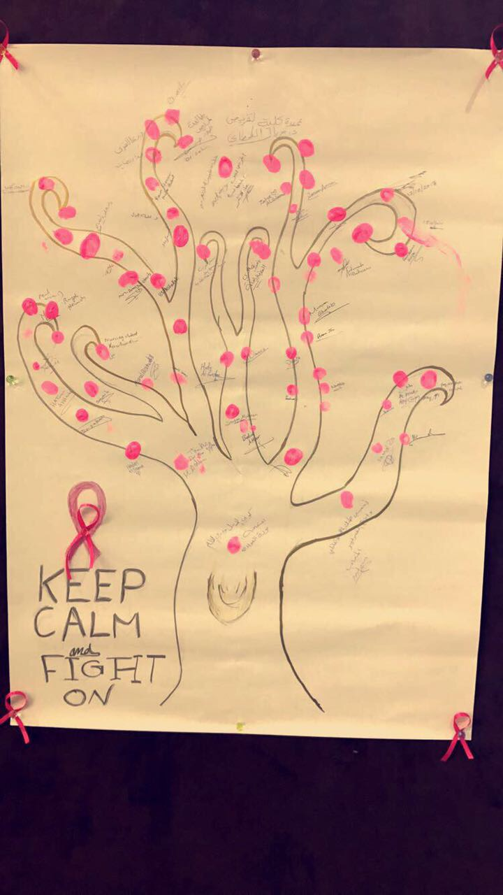

1. **University Harvest**

The College of nursing was participating in the “Third Annual Conference for the harvest of the university community”. This event was held on 21 of November, 2017 in “Imam Abdulrahman Bin Faisal University”.

Objectives:

1. Present to the community about the college of Nursing and its vision and mission.

2. Achieve the social responsibility through this event as a part of the community services.

3. Strengthen communication between the college and other communities.

Activities:

Under the attendance of His Royal Highness Prince Saud bin Naif bin Abdulaziz, Imam Abdulrahman bin Faisal University held the third annual Conference of the university to the community, which aims to promote community investment by strengthening communication between the university and the various sectors of society.

The conference began with a wonderful reading of the Holy Quran and then His Royal Highness Prince Saud bin Nayef presented his speech.

Then the Dean of Community Service and Sustainable Development, Dr. Najah Al-Qarawi, announced the winning projects for the Sanabel Harvest Award.

Our College participated in a project called Home Health Care in the Gulf Girl, where our college won the sixth place. A professional development program developed to cater for the needs of a certain segment of the population, and the Centre for good donorship of the Gulf Girl Association oversees its implementation with a view to providing special home care for groups in the community who need care: as elderly women in their homes, helping families take care of their children or Special needs. With the opening of non-traditional employment prospects for girls that meet the needs of society, raise the health, cultural, environmental and physical quality of the families of working girls, and instill self-confidence during fieldwork.

In addition to training at the University of Imam Abdulrahman bin Faisal College of Nursing and 4 days of practical training in social institutions, to obtain a certificate of passing a course approved by Imam Abdulrahman bin Faisal University with the qualification of short courses including: Computer, English, first aid and development Self, then they are hired by the center of Good donorship.

After that, the President of Imam Abdulrahman Bin Faisal University Dr. Abdullah Al-Rabesh presented his speech

finally, the Prince thanked the successful partners and the winning projects.

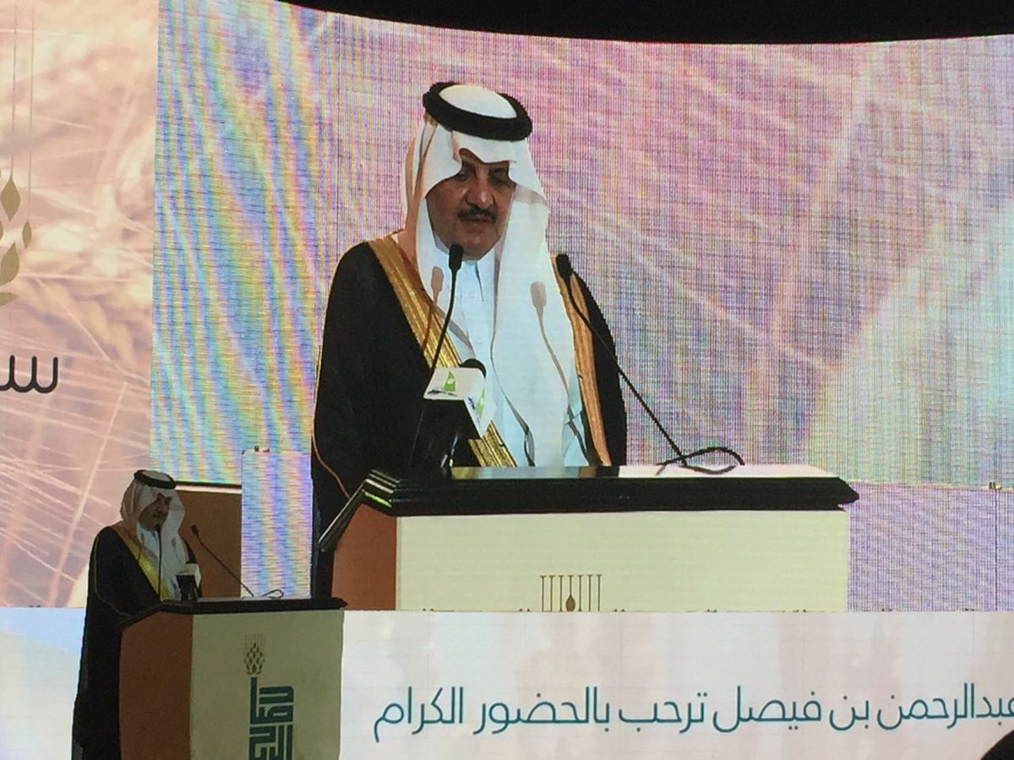

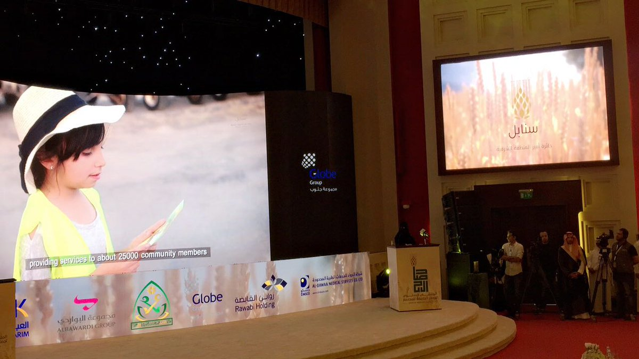

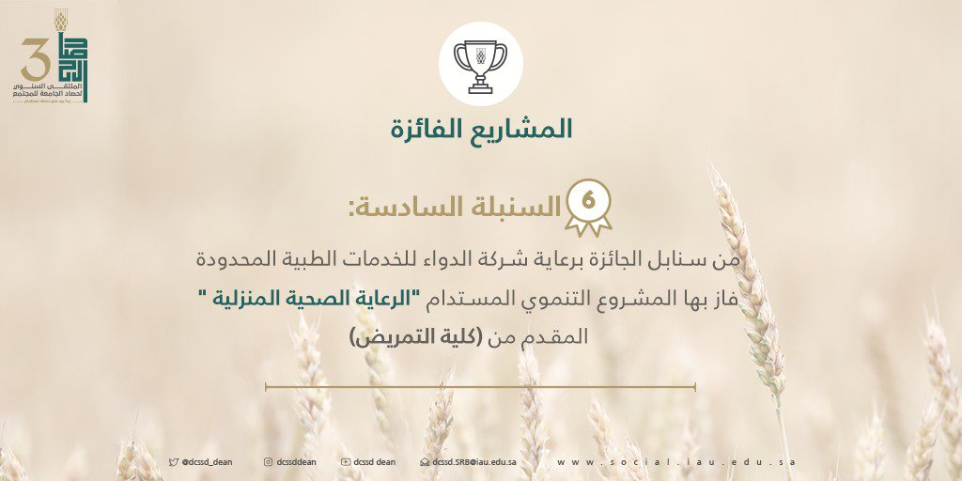

1. **Awareness about First Aids, Burn, Wounds, Nose bleeding for primary level**

In the name of God the Merciful, peace and blessings be upon the Messenger of Allah The College of nursing under Awareness & community service unit was visited the national Education Schools and participated in the hours of activity of the school.

The program was Awareness about First Aid, Burn, Wounds, Nose bleeding for primary level

It is started with lecture about these topics presented by Mrs.Seham Al.Rashedi.

And three corners with different idea:

First Corner about: How to deal with wounds.

Second Corner about: first aid kits and what they contain.

Third corner contain some gifts for children .

Setting: National Education Schools

Date: 11 \12\2017.

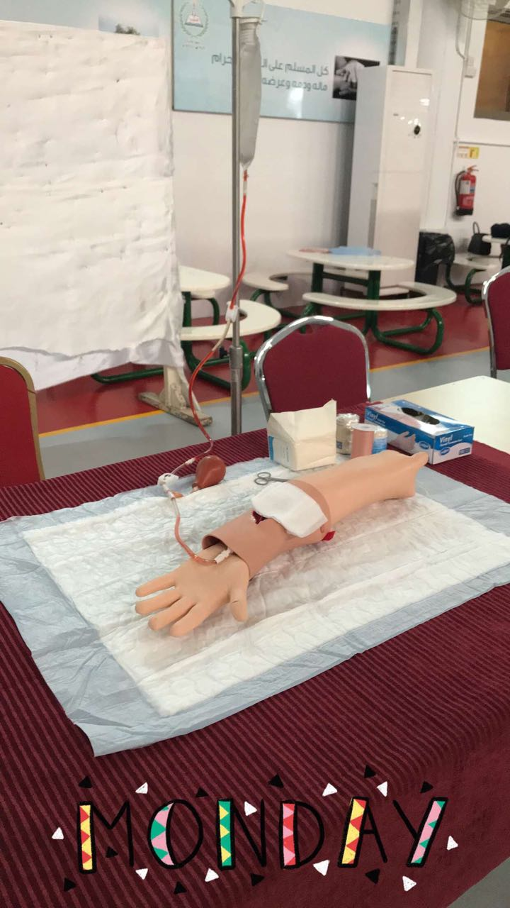

1. **Nutrition**

In the name of God the Merciful, peace and blessings be upon the Messenger of Allah The College of nursing under Awareness & community service unit was visited the national Education Schools and participated in the hours of activity of the school.

The program was Awareness about the Nutrition (healthy and non-healthy food)

It is started with lecture about these topics presented by Mrs.Seham Al.Rashedi.

• A cartoon character was brought in to attract children

And three corners with different idea:

First Corner about: Different between healthy and non-healthy food.

Second Corner about: drawing on the faces of children

Third corner about: coloring cards for children

Setting: National Education Schools

Date: 14 \12\2017.

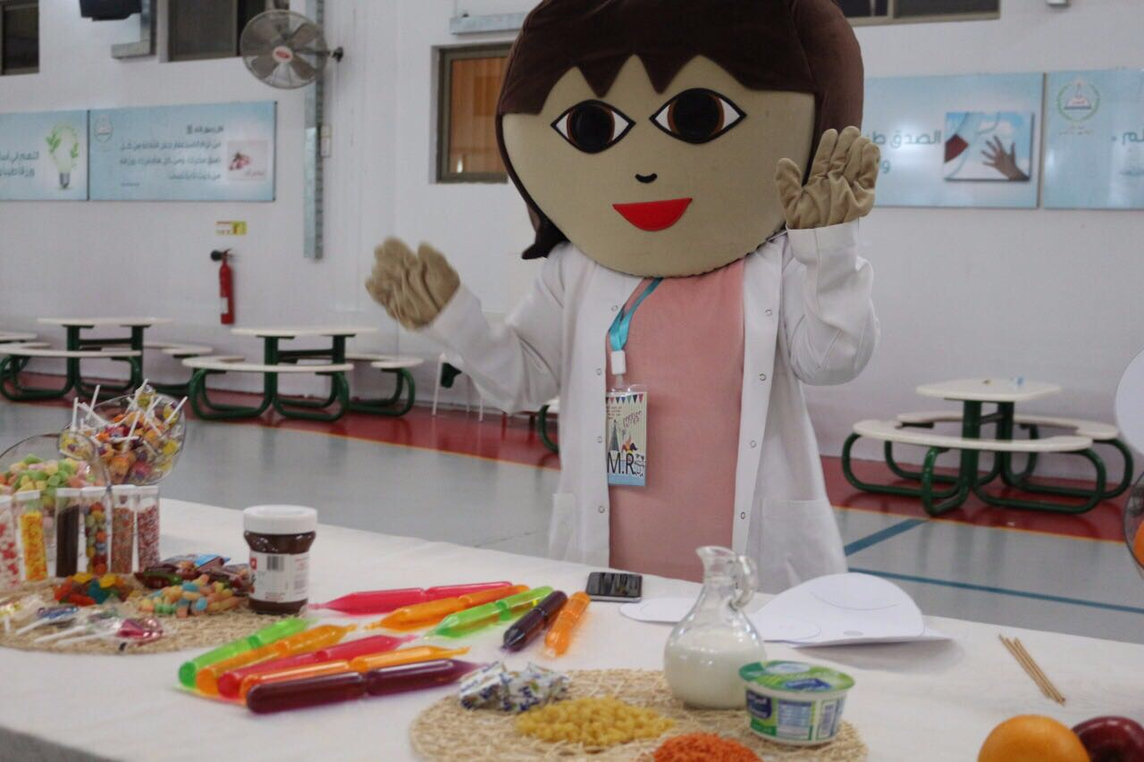

1. **Osteoporosis**

In the name of God, the Merciful, peace and blessings be upon the Messenger of Allah The College of nursing under Awareness & community service unit was visited Eighth high school and participated in the hours of activity of the school.

The program was awareness about the osteoporosis.

The lecture divided to different ideas:

First: Definition of osteoporosis.

Second: The causes of osteoporosis and what is the manifestation of osteoporosis (video).

Third: Ways to prevent osteoporosis.

Fourth: Exercise with students.

Fifth: Ask some Questions and motivational awards.

Setting: Eighth high Schools.

Date: 7 \2\2018.

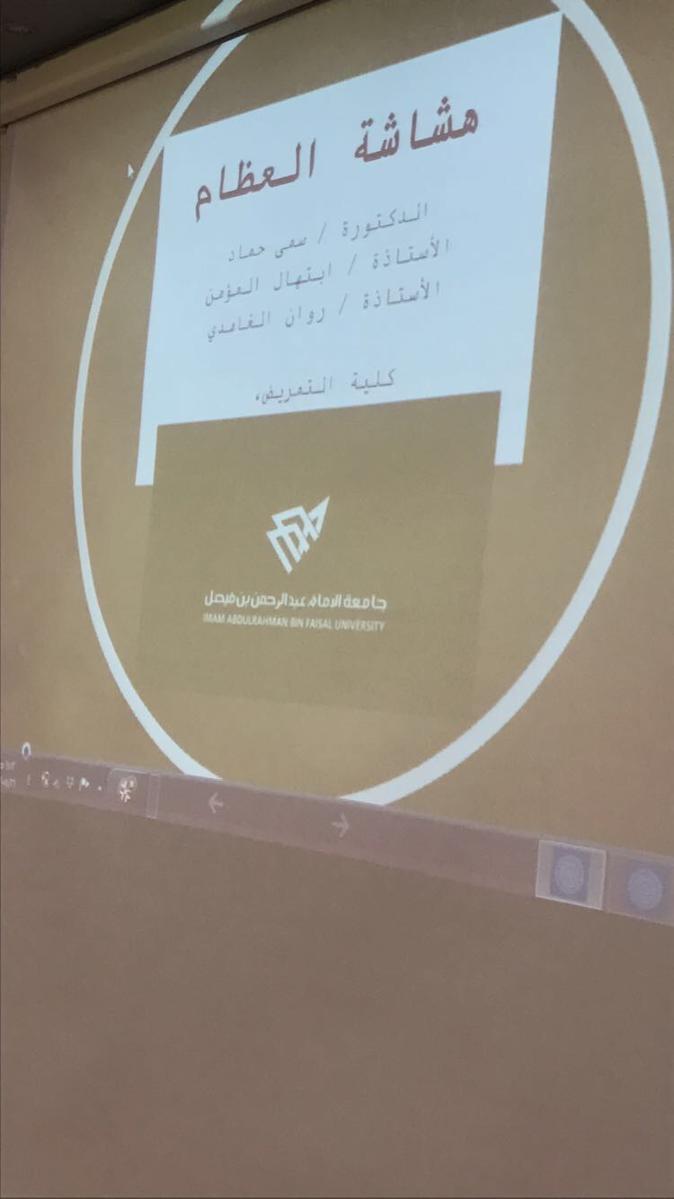

1. **Mental health world**

The College of nursing was participating in Mental Health world day by giving a lecture about “Mental health promotion among secondary school “ This event was held on the 21th of Jumadal -Awwal, 1439 in the eighth secondary school, in Alkhober.

Target group was the secondary school students.

Objectives:

Describe mental –health Concept

Identify the characteristics of mentally healthy people

list means that enhance positive mental

Apply some tips that enhance positive mental

The participation was consisted of three parts, which are:

Introduction about the topic

Lecture part

Questioning & group discussion

Prize giving

Activities

1. There was active discussion and interaction to clarify some points.

2. Discussion opportunity was provided.

3. Many behavioral problems were discussed.

Recommendation

Overall, the event was successful and achieves its goal through the community service. We hope to have a series of lectures and training workshop for the students in how to study ineffective way and how to face different challenges expected at this life stage.

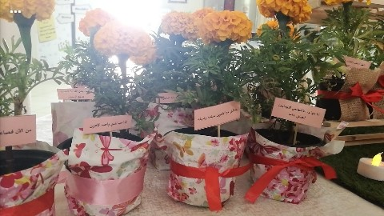

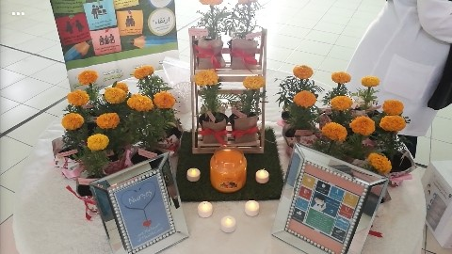

1. **"Environmental Health Care Safety"**

The safety Exhibition will conducted in the King Fahad University Hospital, governmental hospital, affiliated to Ministry of Health, in the Eastern Province, AL Dammam, Saudi Arabia.

. The period from the beginning of April 3nd, 2018 till the 10th.

**Participants:**

* College of Nursing:

The participants who will selected from students, interns, and faculty staff, clinical Instructors.

* King Fahd Hospital of the University (KFHU): Health care workers
* Community agencies: All community leaders and stakeholders.