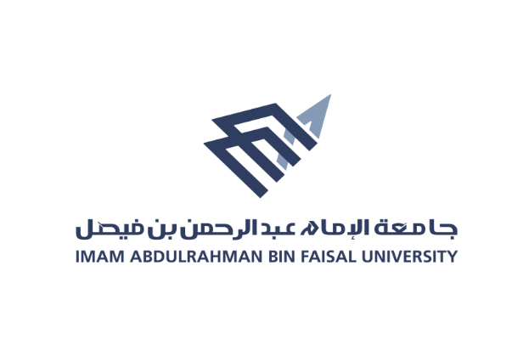

**كليــــــــة التــمــــريض**

**College of Nursing**

**Annual Report 2020 - 2021**

**Introduction**

This report represents the activities that have been achieved through the "Awareness and Community Service" unit. As a support unit for the Deanship of Community Service and Sustainable Development at Imam Abdul Rahman Bin Faisal University. The unit operates considering the social, environmental, and economic aspects aimed at providing health services to the community.

**Mission**

Activating the role of Imam Abdul Rahman bin Faisal University (College of Nursing) in community service and sustainable development with its social, economic, and environmental dimensions to meet the needs of society.

**Vision**

Enhancing the role of "community service" for students and employees of the college.

**Achievements of the Awareness and Community Service Unit for the academic year 2020-2021**

The Faculty of Nursing at Imam Abdul Rahman bin Faisal University seeks to raise the level of community service and align the college's mission with the university's mission and the vision of the Kingdom of Saudi Arabia 2030 in developing learning and education and improving the level of health, through the college's participation in awareness campaigns through concerted efforts by faculty members and students in Systematic and extracurricular activity with the aim of achieving social responsibility

**1. World Mental Health Day**

To enhance the role of social partnership between government institutions, which contribute to the development of work and the consolidation of relations through continuous cooperation, the Awareness and Community Service Unit participated with the participation of faculty members to activate the “You are not alone” campaign

\***Objectives**:

1. Educating mothers of children with special needs

**Category**: extracurricular activity

**Target group**: women

**Names of the executors of the event:**

Dr. Nima Kamal

**Implementation date**: 10/15/2020 corresponding to 2/28/1442 AH

**Place of implementation**: Skills development for day care

**Methods and tools**:

- Preparing a lecture through the PowerPoint program.

Pictures:

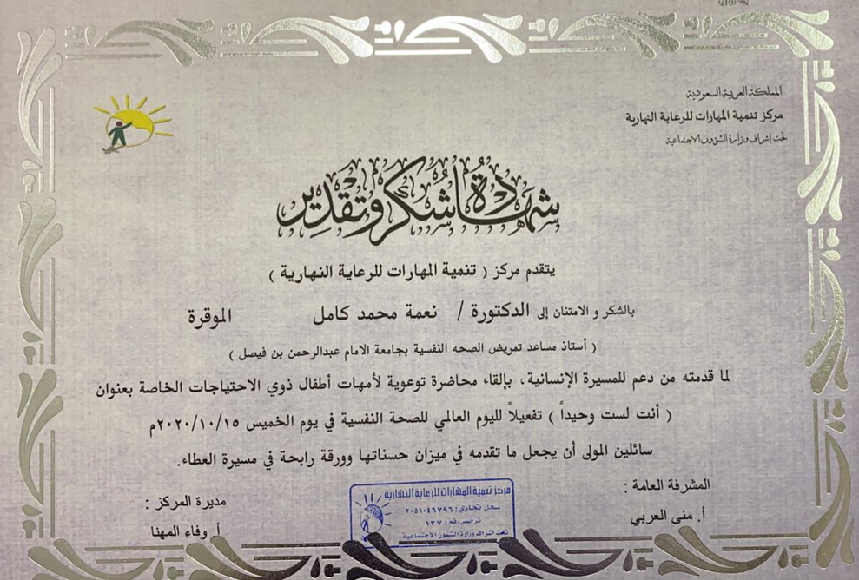

**2. World Diabetes Day event**

The College of Nursing, represented by the Department of Nursing Care and the Awareness and Community Service Unit, held the World Diabetes Day event through the Zoom program (Corona Pandemic), under the supervision of female faculty members at the College of Nursing, Imam Abdul Rahman Bin Faisal University.

**Location**: Ataa Al Khair Center.

**Today and date**: Monday: 1/4/1442 corresponding to 11-16-2020.

**Time: 10-12 pm**

**Category**: **community** service

**Target group: Families in the Ataa Al Khair Center**

**Names** of the executors of the event:

1. Dr. Naglaa Al-Saleh

2. Mrs. Hanan Abu Qurain

3. Mrs. Badria Abu Talib

*Content:

The event included several topics, as follows:

1. Definition of diabetes.

2. reasons.

3. Signs of high and low sugar.

4. Ways to prevent it.

5. Treatment methods.

**3. The effectiveness of the World Antibiotic Day**

The College of Nursing, represented by the Awareness and Community Service Unit, held an awareness program entitled: Antibiotics (handle them with caution) during the International Week, in the middle and first secondary schools in Hindi, under the supervision of a faculty member at the College of Nursing, Imam Abdul Rahman bin Faisal University, and second- and fourth-year students.

**The campaign included several topics on antibiotics, including:**

1. Definition and modes of action of antibiotics

2. Ways to benefit

3. Types of antibodies

4. Matters that antibiotics do not treat

5. Complications of using antibiotics

6. Risks of overdose

7. How to resist antibiotics

8. Misconceptions

9. Facts about antibiotics

10. Medical advice

**Category**: community service

The target group: middle and first secondary students and teachers in Hindi in Madinah.

**Names of the executors of the event:**

1. Fatima Al-Qahtani and the second year students

**Implementation date**: 4/2/1442 AH corresponding to 11/17/2020

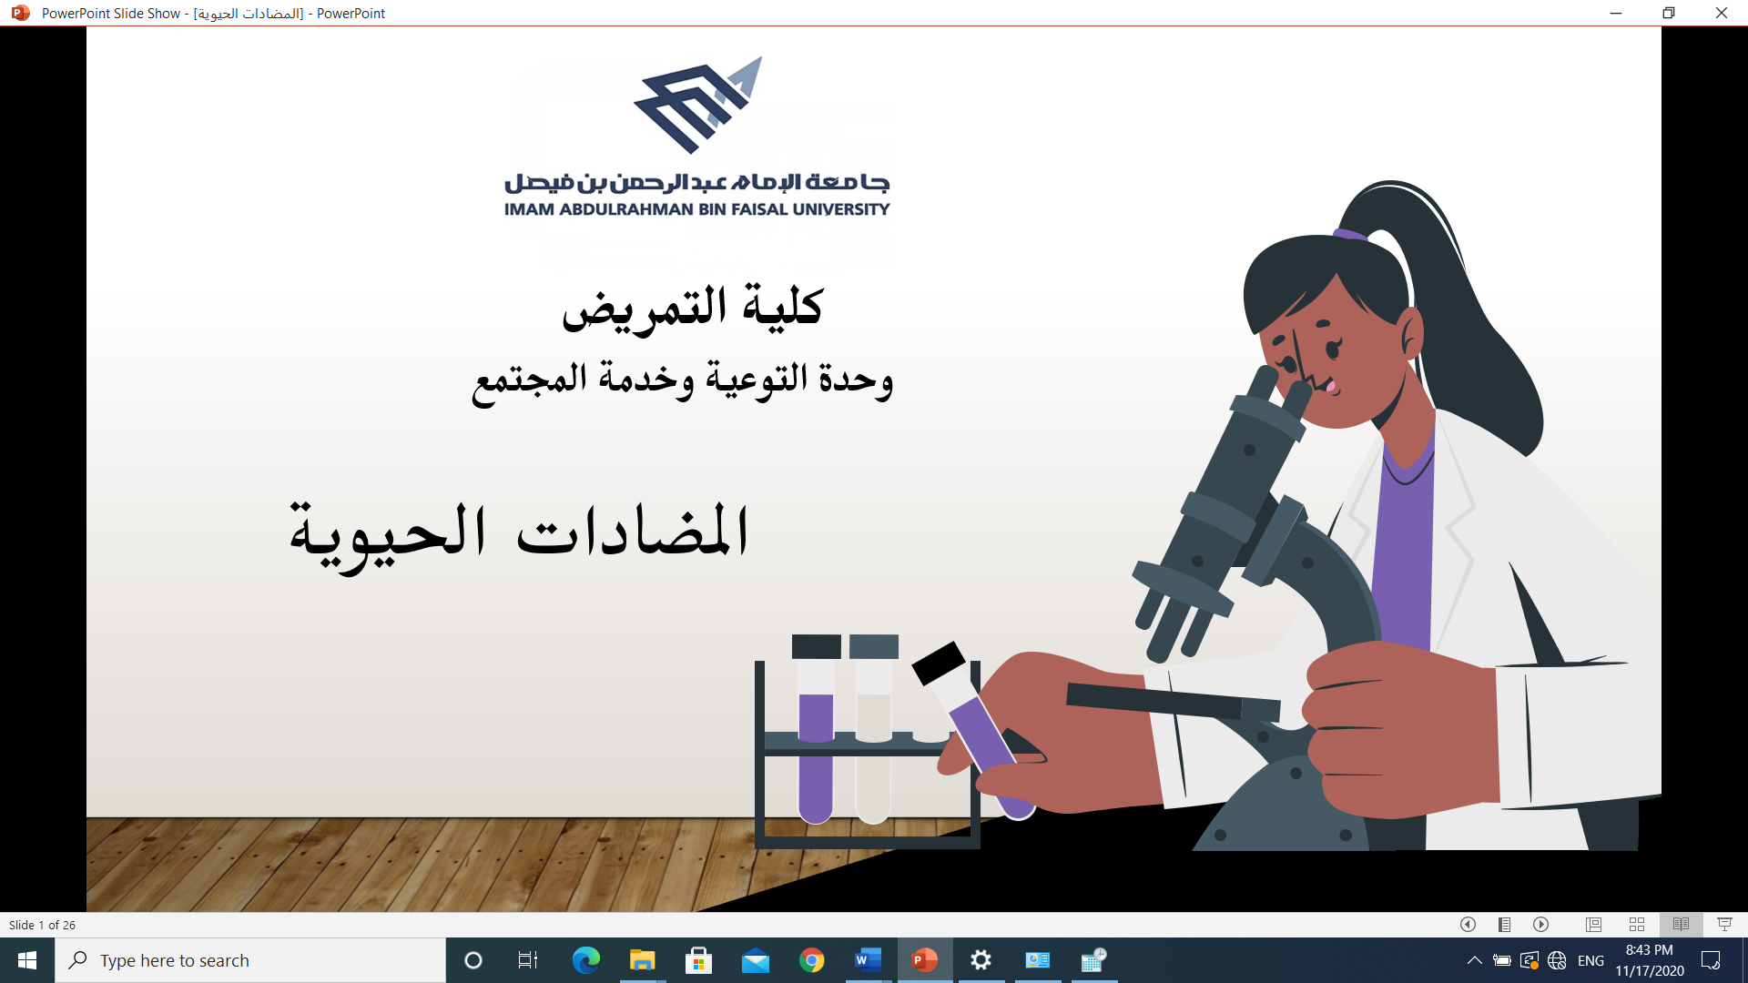



**4. The World Antibiotic Day event**

The College of Nursing, represented by the Awareness and Community Service Unit, held an awareness program entitled: Antibiotics (handle them with caution) during the International Week, at the Ataa Charity Association in Al-Khobar, under the supervision of a faculty member at the College of Nursing, Imam Abdul Rahman Bin Faisal University

**Category**: community service

**Target group**: Families in the Ataa Al Khair Center

**The names of the executors of the event**: Ms. Fatima Al-Qahtani

**Implementation date**: 11/18/2020 corresponding to 4/3/1442 AH

**Place of implementation**: Ataa Al-Khair Center (Gulf Girl) in Al-Khobar

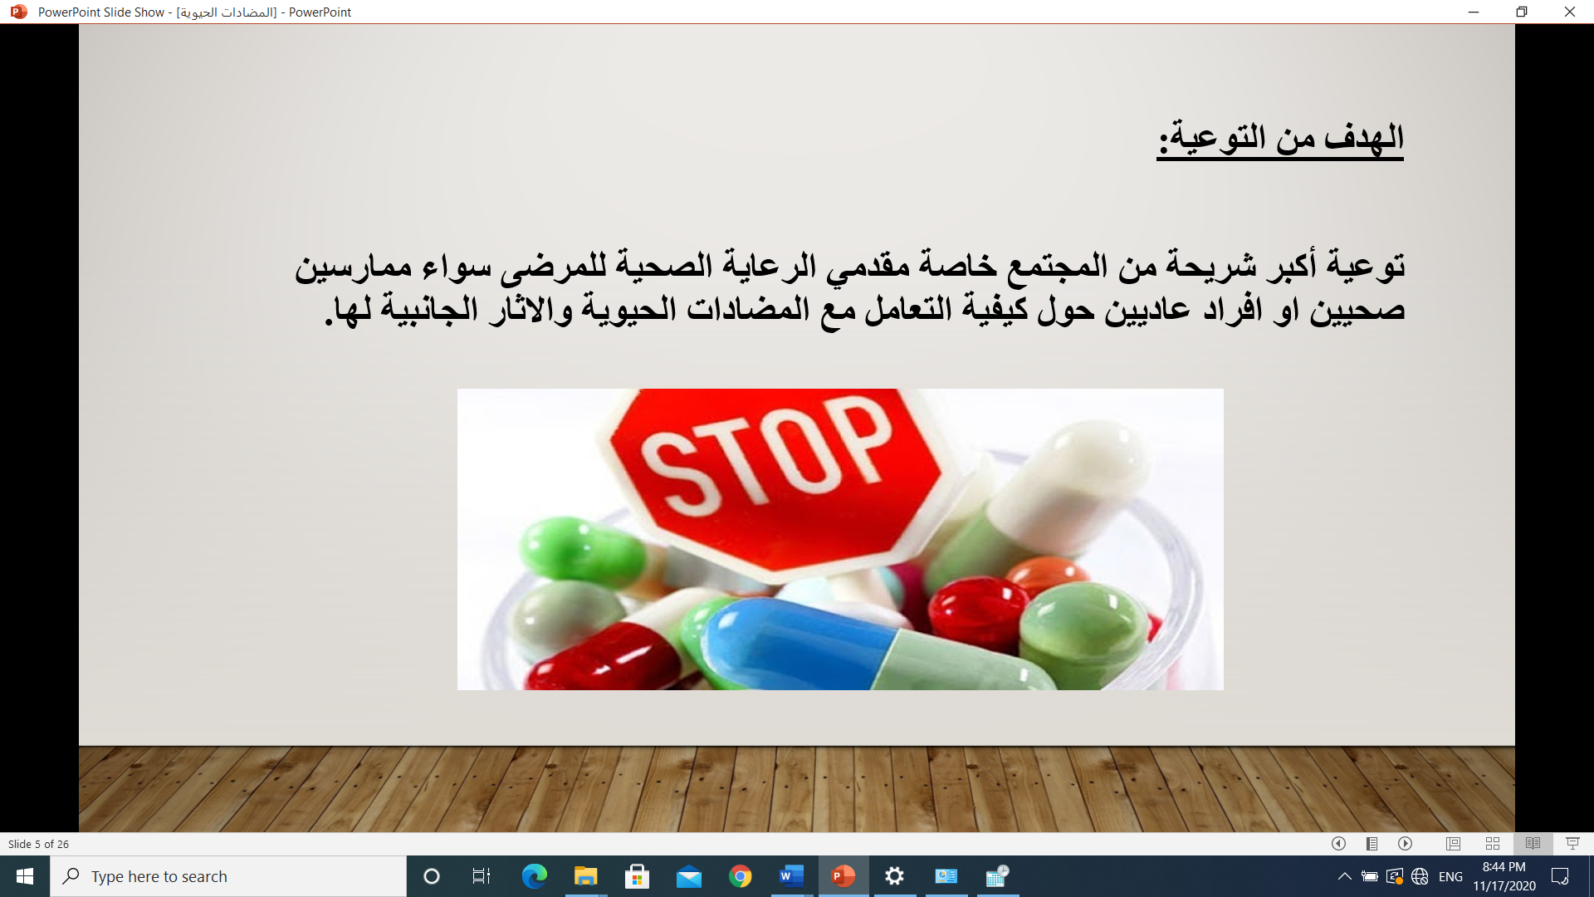

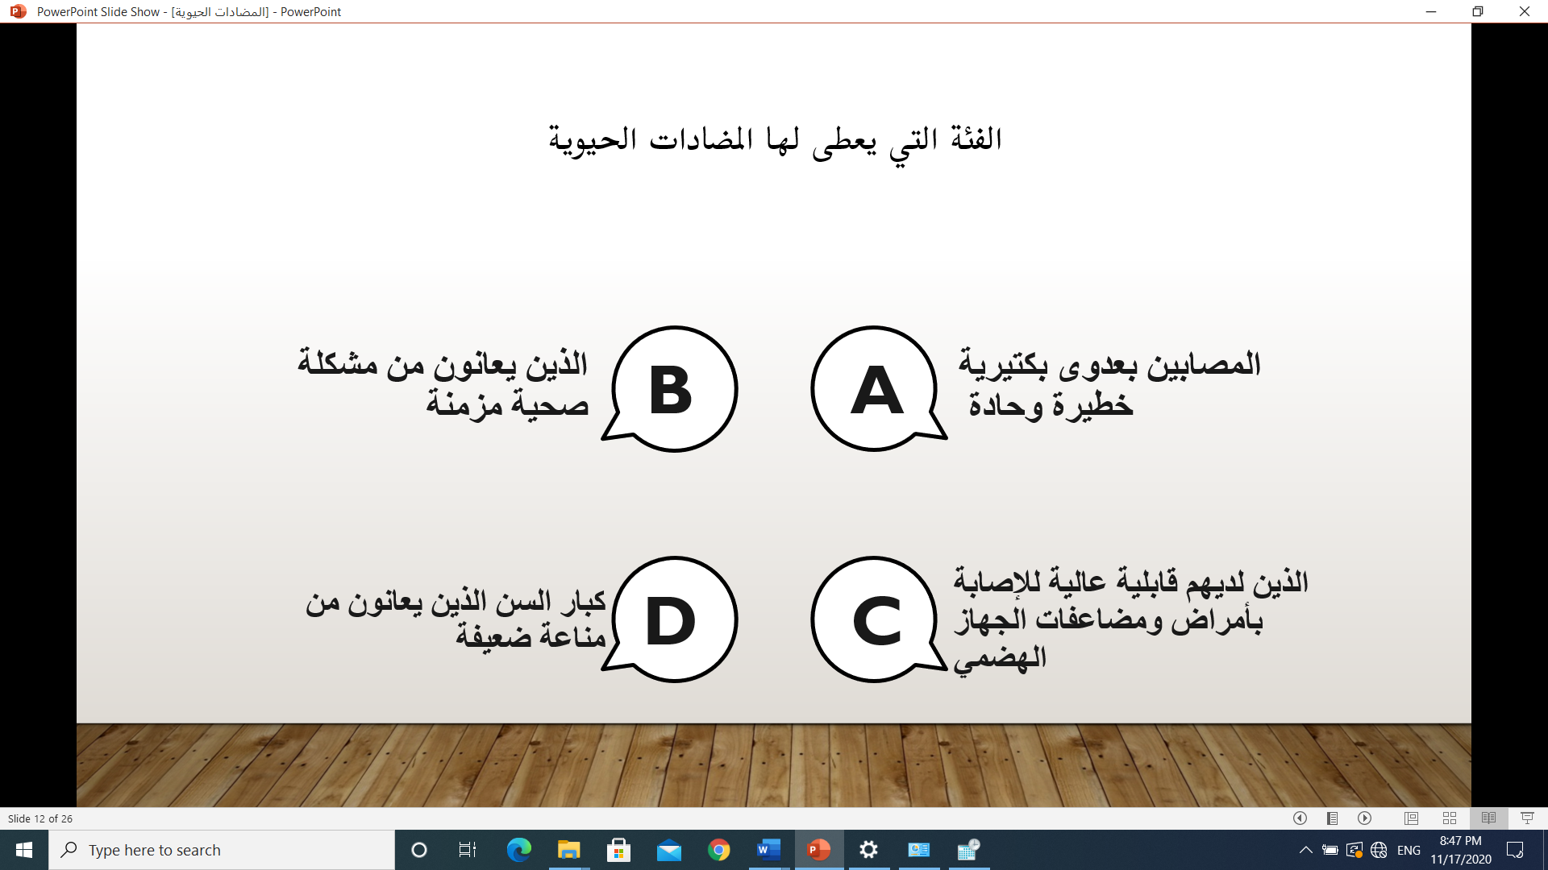

**5. World Diabetes Day event**

The College of Nursing, represented by the Awareness and Community Service Unit, held an awareness campaign about diabetes during pregnancy, under the supervision of faculty members in the obstetrics and gynecology track (clinical track) and master's students.

**Classification**: methodical activity

**Target group**: expectant mothers

**Implementation date**: 11-22-2020 corresponding

7 - 4 - 1442 AH

**Place of implementation**: Maternity and Children's Hospital

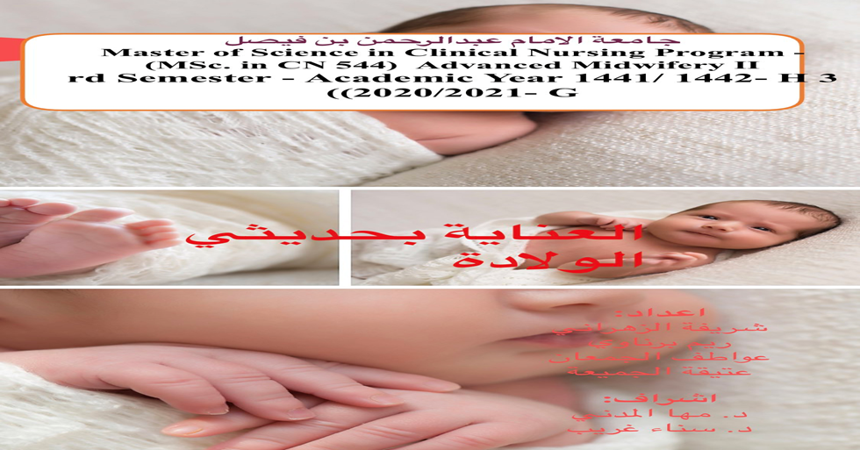

**Names of the executors of the event:**

Dr. Sahar Al-Shamandi.

Dr. Sana Gharib

Dr. Maha Al-Madani.

Dr.Areej Haitham

Master's students, a clinical track (Gynecology and Obstetrics)

**6. An event on International Children's Day**

The College of Nursing, represented by the Community Service Unit, activated the International Children's Day at the Ataa Al-Khair Association in Al-Khobar

\***Objectives**:

1. Highlighting the value of the child to society.

2. Sharing the difficulties facing the child.

3. Discussion of some of the most common diseases in children such as obesity.

**Target group:** mothers and children

**Names of the executors of the event**:

Dr.Sama Hamad

Dr.Ahlam Hussain

Master's students for the course of pediatric nursing

**Implementation date**: 11-26-2020 corresponding to 4-11-1442 AH

**Place of implementation**: Ataa Al-Khair Charity Center (via the Zoom program)

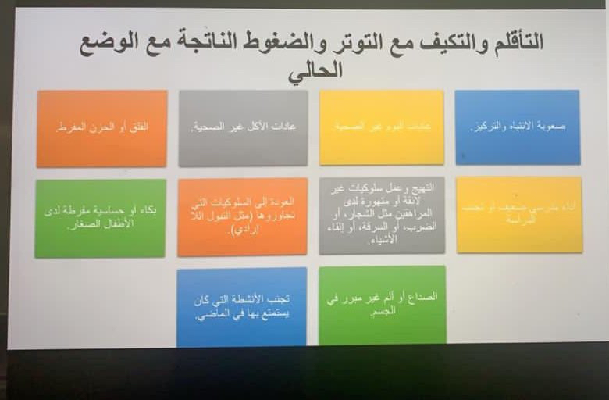

**7. International Children's Day event**

The College of Nursing, represented by the Awareness and Community Service Unit, activated the International Children's Day, in the Baby Shark Kindergarten in Dammam. Where the event, which was presented through the Zoom program, included competitions for children, a paragraph on how to make cakes, and finally exercise, and gifts were distributed to children by sending them a day before to kindergarten.

**Category**: community service

**Target group**: Children in Baby Shark Kindergarten

**Implementation date**: 15-4-1442, 30-11-2020

**Place of implementation**: Baby Shark Kindergarten in Dammam

**Time:** from 10 am to 12 pm

**Names of participants in the campaign**:

Mrs.Rawan Al-Ghamdi and fourth year students

**Pictures**:

8. **An event on International Children's Day**

To enhance the role of social partnership between government institutions, which contribute to the development of work and the consolidation of relations through continuous cooperation, the Awareness and Community Service Unit, with the participation of faculty members and fourth-year students, participated in a corner to activate the International Children's Day.

**\*Objectives:**

- Enhancing the value of the child and highlighting his role in society.

- Distribution of gifts to children.

- Parents discussing the child's behaviour.

**Target group**: women, children, and men

**Names of the executors of the event:**

Mrs. Rawan Al-Ghamdi

Dr. Heba Al-Mulla.

Mrs.Seham Al-Rashidi.

Fourth year students.

**Implementation date**: 4-23-1442, 8-12-2020

**Place of implementation**: Dental Hospital at Imam Abdulrahman Bin Faisal University.

**Methods and tools:**

- Preparing a corner for the International Children's Day, including gifts and publications, and taking a souvenir photo of the mother and child.

**9. An event on the International Day of Disability**

To enhance the role of social partnership between government institutions, which contribute to the development of work and the consolidation of relations through continuous cooperation, the Awareness and Community Service Unit participated with the participation of faculty members to activate the International Day of Disability campaign.

**Objectives**:

- Educating mothers about the meaning of disability.

- How to deal with them and face difficulties.

Category: extracurricular activity

**Target group:** women

**Names of the executors of the event:**

Dr. Naemah Kamal

**Implementation date:** 1 - 5 - 1442, 16 - 12 - 2020

**Place of implementation**: Ataa Al Khair Center.

**Methods and tools:**

- Preparing a lecture through the PowerPoint program.

**10-International Day of Disability for People with Disabilities**

In order to enhance the role of social partnership between government institutions, which contribute to the development of work and the consolidation of relations through continuous cooperation, the Awareness and Community Service Unit participated with the participation of faculty members to activate the International Day of Persons with Disabilities campaign under the slogan “Not all disabilities are visible”.

\***Objectives**:

- Educating mothers about the meaning of disability.

- How to deal with them and face difficulties.

**Category**: extracurricular activity

**Target group:** women

**Names of the executors of the event:**

Dr. Nima Kamal

**Implementation date:** 3, 4, 5 – 12 – 2020 corresponding to 18, 19, 20 Rabi’ al-Thani 1442 AH

**Place of implementation**: Fatat alkhaleej Center

**Methods and tools:**

- Preparing a lecture through the PowerPoint program.

**Pictures**:

**11. An event on caring for the elderly**

In order to enhance the role of social partnership between government institutions, which contribute to the development of work and the consolidation of relations through continuous cooperation, the Awareness and Community Service Unit participated, with the participation of faculty members, to activate the campaign to care for the elderly with eye diseases through the Zoom program.

\***Objectives**:

- Educating the students of Ataa Al-Khair Center on how to care for the elderly with eye diseases.

**Category**: extracurricular activity

**Target group**: women

**Names of the executors of the event:**

Dr. Naemah Kamal

**Implementation date**: 6 - 5 - 1442, 21 - 12 - 2020

**Place of implementation**: Ataa Al Khair Center.

**Methods and tools:**

- Preparing a lecture through the PowerPoint program.

**12. Educating visitors to the Khobar Corniche**

To enhance the role of social partnership between government institutions, which contribute to the development of work and the consolidation of relations through continuous cooperation, the Awareness and Community Service Unit participated, with the participation of faculty members, to activate the “We Cooperate We Don’t Stop” campaign, as part of the community health course

\***Objectives**:

**10. Educating families in Al-Khobar Corniche of the need to adhere to preventive measures, including wearing a mask, sterilizing hands, and social distancing**

**Target group**: families

**Names of the executors of the event:**

Dr. Feryal Al-Qahtani

Dr. Wafaa El-Desouki

Dr. Hoda Al-Ebiari

Dr. Naglaa Al-Saleh

Dr. Emad Shdeifat

Dr. Amna Omar

Mrs. Rayana Al-Ghamdi

Mrs. Noura Al-Otaibi

Mr.Acer Jamam

Mr.Mohammed Al-Amer

Mr. Robin Iso

Mr.Abdul Rahman Al-Nati

Mr. Daham Al-Enezi

and fourth year students

**Implementation date**: February 27 for one month

**Place of execution**: Al-Khobar Corniche

**Methods and tools:**

- Papers were distributed containing a code that was photographed by visitors to Al-Khobar Corniche, containing all information related to the Corona pandemic

**13 . World Oral and Dental Health Day**

In order to enhance the role of social partnership between government institutions, which contribute to the development of work and the consolidation of relations through continuous cooperation, the Awareness and Community Service Unit participated with the participation of faculty members to activate the World Oral and Dental Health Day

\***Objectives**:

11. Educating children about the importance of caring for dental hygiene and the consequences of not caring for teeth

**Classification**: extracurricular activity

**Target group**: children

**Names of the executors of the event:**

Mrs.Rawan Al-Ghamdi and female students from the fourth year

**Implementation date:** 8-25-1442 corresponding to 4-7-2021

**Place of implementation:** Baby Shark Kindergarten

**Methods and tools:**

The activity was activated through the Zoom program

- Gifts and tools were sent from a brush and others two days before the event to the center